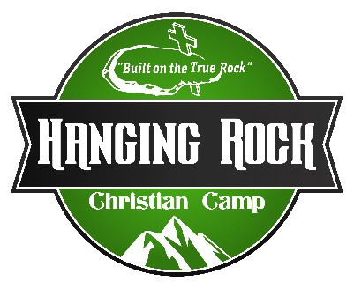

**Position Description**

**Hanging Rock Christian Camp**

**Title:**  Creative/Photographer

**Time: June 1 – July 27, 2025**

**Pay** $300 per week

**Reports to:**  Communications Director or Executive Director

**Responsibilities:**

**Photography/Social Media:**

1. Be responsible for all pictures & videos taken on camp property.
2. Take group picture of all camps and put them on Facebook, Instagram, and website
3. Take pictures/videos of campers and promote them on all social networks.
4. Maintain pictures/videos on website
5. Maintain pictures/videos on the share folder on network.
6. Help with email newsletter for July & August
7. Be able to edit pictures/videos & create content
8. Be able to run Pro-Presenter & sound board for all Main Camp worship sessions.

**Other:**

# a. Help with setup/tear down for camps

# b. Be available to help where needed