Hanging Rock Christian Assembly, Inc.
First Aid - Job Description
2024
Responsible to:
Executive Director
General Responsibilities:
1. To assist in the operation of Hanging Rock Christian Camp consistent with the HRCA mission, goals and objectives.
2. To assist other health personnel in the supervision of all aspects of the Hanging Rock’s Camps medical services.
3. Understand the state requirements for first aid at Hanging Rock.
Specific Responsibilities:
1. Assist in the organization and setting-up of the First Aid Room.
3. Assist in the inventory of necessary medical supplies and equipment.
4. Assist in developing and stocking First Aid Kits for all camps:
5. Assist in maintaining accurate and detailed medical records including:
􀂾 Staff and camper health forms, with special attention to immunization compliance
􀂾 First Aid Log of daily visits
􀂾 Progress notes for campers, staff, and faculty with complex health issues
􀂾 Daily reports of restricted activities for campers, staff and faculty
􀂾 Medication Administration Records
􀂾 Incident Report forms

6. Assist in providing a faculty orientation to health services at camp which includes:
􀂾 Overview of standing orders, First aid hours, specific camper health and social needs, Health Center rules, emergency procedures, growth and development of age groups, staff health assessment of campers, policies on contacting parents, transportation to outside health facilities, accident prevention, nutrition, and first aid in the camp setting.

8. Check all health forms of campers and staff and inform Executive Director of any specific health problems.

9. Make sure all campers have any meds required to take while at camp.

10. Be available for camps. Be where campers are: If that means going to low ropes or pond activities you are there.

11. Help turnover camp after each session. Make sure first aid room is clean and mopped and disinfected. Also help turnover rooms in the Hilton.

Minimum Requirements:
1. Experience working with children and young adults
2. Ability to originate, update, and/or monitor health care, maintain records, and implement the health care plan and standing orders
3. Current CPR and First Aid/AED certifications
4. Desire to work and live in a camp community
5. Ability to relate to one’s peer group
6. Ability to accept supervision and guidance
7. Ability to lead or assist in the teaching of an activity
8. Good character, integrity, and adaptability
9. Enthusiasm, sense of humor, patience and self control
10. Ability to meet the public
Compensation:
$400 per week. Week includes Sunday-Saturday.
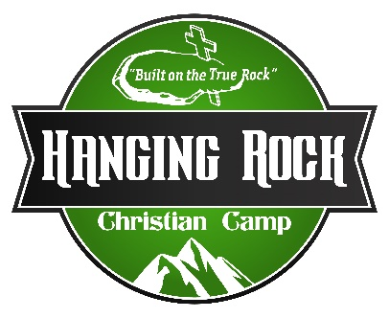

___________________________________ _____________________________________
Employee Date Executive Director Date

